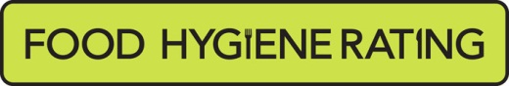  Food Hygiene Rating Scheme: Request for a re-visit | 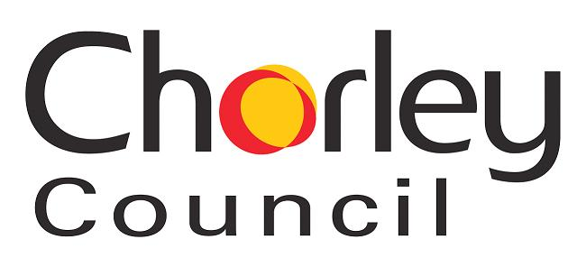 | 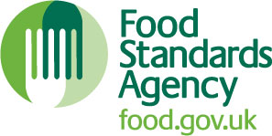

Notes for businesses:

- As the food business operator of the establishment you have a right to request a re-visit for the purposes of re-rating if you have taken action to rectify the non-compliances identified at the time of inspection.
- You can make one request for a re-visit per each planned statutory inspection by the local authority and you can make this at any time after the statutory inspection provided that you have made the required improvements. Some local authorities will charge for this re-visit. The letter informing you of your rating will indicate this and the amount charged. Where a charge is made, there is no limit on the number of requests you may make.
- You must provide details of the improvements made with your request, including supporting evidence where appropriate.
- If the local authority considers that you have provided sufficient evidence that the required improvements have been made, and provided that a three month ‘stand still’ period has passed since the statutory inspection, the local authority will make an unannounced visit. This will take place within three months of the end of the three month ‘stand still’ period or within three months of the request if this made after the ‘stand still’ period (if you were only required to make permanent structural improvements or repairs or to upgrade equipment, the local authority can choose to carry out the requested re-visit sooner than this). Where the local authority charge for the re-visit, the stand-still period will not be applied and the re-visit will be carried out within three months of the receipt of your request and payment of the fee.
- The local authority officer will give you a ‘new’ food hygiene rating based on the level of compliance that is found at the time of the re-visit - you should be aware that your rating could go up, down or remain the same.
- To make a request for a revisit, please use the form below and return it to the food safety officer from your local authority – contact details are provided with the written notification of your food hygiene rating.

Business details
Food business operator/proprietor

Business name

Business addresses

Business tel. number |  | Business email

Inspection details
Date of inspection |  |  |  |  | Food hygiene rating given

Action taken
Please describe the remedial action you have taken with reference to the issues identified in the inspection letter/report provided to you by your local authority with your score:
Compliance with food hygiene and safety procedures

Compliance with structural requirements

Confidence in management/control procedures

Please provide any other supplementary evidence (e.g. photographs, invoices, copies of relevant HACCP documentation etc.).

Signature
Name in capitals

Position |  | Date
Please return this form to food.team@chorley.gov.uk with confirmation of payment reference.
Payment of the fee of £208 must be made by contacting Customer Services on 01257 515151.

