2023 Air Quality Annual Status Report (ASR)
In fulfilment of Part IV of the Environment Act 1995 Local Air Quality Management, as amended by the Environment Act 2021
Date: June 2023

Information | Chorley Council Details
Local Authority Officer | Dr Matt Evans
Department | Environmental Health
Address | Civic Offices  Union Street  Chorley  Lancashire  PR7 1AL
Telephone | 01257 515151
E-mail | Matt.evans@chorley.gov.uk
Report Reference Number | ASR23
Date | June 2023

Executive Summary: Air Quality in Our Area

Air Quality in Chorley
Air pollution is associated with a number of adverse health impacts. It is recognised as a contributing factor in the onset of heart disease and cancer. Additionally, air pollution particularly affects the most vulnerable in society: children, the elderly, and those with existing heart and lung conditions. There is also often a strong correlation with equalities issues because areas with poor air quality are also often less affluent areas,.
The mortality burden of air pollution within the UK is equivalent to 29,000 to 43,000 deaths at typical ages, with a total estimated healthcare cost to the NHS and social care of £157 million in 2017.
The principal pollutants of concern within Chorley are those associated mainly with traffic, these being Nitrogen Dioxide, and Particulate Matter. The Council currently monitors Nitrogen Dioxide emissions via a network of diffusion tubes and currently has no declared Air Quality Management Areas within the Borough. Available trend data over the last five years indicates that levels have generally reduced but have now stabilised. This was likely because of the Covid-19 pandemic on traffic flows up to 2021. The results from 2022 show no areas of exceedance or near exceedance of the national objectives within the Borough. The areas with the highest readings correspond to the section of the A6 entering Chorley town centre from the north (CH60, CH61 and CH62). It is noted that there is insufficient data available for the monitoring sites introduced during the 2021 monitoring period from which to ascertain a definite trend, this will be kept under review.
However, given the continual evidence identifying the harmful effects of both Particulate Matter and Nitrogen Dioxide, along with the Council’s commitment to work with partners on the public health agenda, the Council’s duties under the Local Air Quality Management regime, combined with the significant development within the area, it is important that work continues to maintain and improve the air quality within the borough.
To that end, the Chorley Council will continue to identify measures to improve and maintain the air quality within the Borough, including ensuring developments do not adversely affect or significantly contribute to pollutant levels. This will be helped by the adoption of a Clean Air Strategy.

Actions to Improve Air Quality
Whilst air quality has improved significantly in recent decades, there are some areas where local action is needed to protect people and the environment from the effects of air pollution.
The Environmental Improvement Plan sets out actions that will drive continued improvements to air quality and to meet the new national interim and long-term PM_{2.5} targets. The National Air Quality Strategy, due to be published in 2023, will provide more information on local authorities' responsibilities to work towards these new targets and reduce PM_{2.5} in their areas. The Road to Zero details the approach to reduce exhaust emissions from road transport through a number of mechanisms; this is extremely important given that the majority of Air Quality Management Areas (AQMAs) are designated due to elevated concentrations heavily influenced by transport emissions.
During the first half of 2022 Chorley Council reviewed and updated the Clean Air Strategy developed in 2021. Since the initial draft of the Clean Air Strategy, Chorley Council launched a separate Climate Change strategy to reaffirm our commitment to the Climate Emergency which was declared in November 2019. There is some crossover between the Clean Air Strategy and the Climate Change strategy. Therefore, for consistency and accountability some actions were reviewed and incorporated elsewhere. The Clean Air Strategy is available on the Council’s Air Quality website, using this link to the Chorley Air Quality webpage.
Air Quality concerns were raised and incorporated into the Part One Preferred Options of the Central Lancashire Local Plan in conjunction with colleagues in South Ribble and Preston City Council which went out for consultation in late 2022. We will continue to feed into the Local Plan during 2023.
Chorley marked Clean Air Day 2022 with social media posts and suggestions for residents to get involved in our Air Quality programme. Part of this involved launching “Ready to Burn” campaign, promoting active travel as an alternative to driving and undertaking a walking, cycling and wheeling consultation during 2022 to gather residents’ views of the issues, barriers and wants with respect to active travel (further information on the consultation is in the ‘Local Engagement and How to get Involved’ section).
We promote flexible and homeworking to reduce commuting and avoidable travel and have adopted a hybrid-working charter, incorporated into business plans by service leads.
Improved access to Electric Vehicles charging options is on-going and being pursued through the Climate Change Strategy and programme of work.
Chorley Council is a member of the AQHub and LGA network groups for Air Quality to share best practice and learning from other local authorities.
Key actions the Council will be looking at over the next year included:
- Publish the updated Clean Air Strategy
- Continuing with the diffusion tube monitoring programme
- Review the performance of continuous air quality Zephyr monitors
- Continue to consider air quality for all relevant planning applications
- Continue to liaise with colleagues across the Council and with South Ribble and Preston City councils to develop the revised Central Lancashire Local Plan
- The development of an Air Quality Planning Guidance note, setting out how and when air quality issues need to be considered as part of the planning process
- Encourage greater use of public transport and alternative forms of travel, including the provision of electric vehicle charging points through the planning system
- We will continue to carry out the inspections and enforcement of permitted premises within the borough under the Environmental Permitting Regulations
- Through the Climate Emergency work we will continue to embed air quality actions and improvements through the Council’s operations
- Working with third sector partners to encourage active travel and make our greens spaces more inviting
• Work with Lancashire County Council and the Highways Authority on improved active travel infrastructure and representing Chorley in the development of the Local Cycling and Walking Infrastructure Plan.

Conclusions and Priorities
The results from the 2022 monitoring programme and review of the government data have identified no areas of likely exceedances of the national objective values for any of the pollutants of concern. The monitoring programme has identified that the nitrogen dioxide levels are low across the Borough at sensitive receptor locations.
All existing monitoring locations have shown a stabilisation in Nitrogen Dioxide concentrations on previous years. The monitoring sites introduced in 2021 also appear stable, but with only two years of readings there is not yet sufficient data to draw a firm conclusion.
Chorley Council will continue to monitor the NOx readings along the A6 passing through Chorley town centre, as this is an area of higher readings in comparison to others. As a priority over the coming months the Council will continue to work with partner organisations on ways to reduce PM pollution across the Borough, and with neighbouring local authorities on the development of the Central Lancashire Local Plan to include guidance for developers. The document is required to ensure all developments adequately address air quality impacts.
In addition, Chorley Council have relaunched the Clean Air Strategy in to drive forward air quality improvements throughout the Borough and will be working on a number of actions to achieve this. Monitoring locations will also continually be reviewed across the Borough to maintain their relevance.

Local Engagement and How to get Involved
Chorley Council welcome scrutiny and suggestions from residents about our Air Quality monitoring programme. To get involved in work to tackle air pollution within Chorley Borough; or for more information on how to reduce your personal emissions, please contact Chorley Council Environmental Health Department on 01257 515151 or e-mail contact@chorley.gov.uk.
Air Quality is an issue that everyone can take responsibility for and make small changes to achieve improvements. Further information is available on the Council’s Air Quality website, using this link to the Chorley Air Quality webpage, and our Climate Change website, using this link to the Chorley Climate Change webpage.
To promote active travel as an alternative to driving Chorley Council carried out a walking, cycling and wheeling consultation during 2022 to gather residents’ views of the issues, barriers and wants with respect to active travel.
The results showed the most popular infrastructure measures were new segregated cycleways, pedestrianised areas, and incentives for residents/visitors to walk or cycle. Other issues concerned road safety, cycle parking and storage, impact on vulnerable groups, personal barriers, and health.
Following this, several actions arising from the survey were developed to:
  - Assess provision and distribution of secure cycle storage facilities to ensure they are attractive to use and near to where people need to go.
  - Link with partners or leisure colleagues to investigate potential of promoting cycle training, group leisure opportunities and cycle maintenance/repair workshops.
  - Develop and deliver public communications regarding active travel benefits, linked to climate change and air quality through the website and social media.
As a District Council, Chorley is not able to progress some actions requested by residents directly, however, comments relating to other projects were collated and passed onto the responsible body to investigate joint-working opportunities, e.g. Canal towpath improvements. As Lancashire County Council is the responsible highways authority, comments from residents are being raised as part of on-going infrastructure work and in developing the Local Cycling and Walking Infrastructure Plans for Lancashire.
Further opportunities to voice opinions on air quality, climate change and the environment are regularly posted on our online consultation portal, link to Citizen Space.
Our social media pages also regularly suggest ways we can all minimise our air quality and wider environmental impact.
Chorley Borough has many cycle routes that can be used for commuting as well as leisure purposes. More information can be found on the Check Out Chorley website: Link to Cycling on Check Out Chorley.
Chorley Borough has good train connections to the rest of the North West, from railway stations at Chorley, Buckshaw Village, Euxton, Adlington, Croston and Bamber Bridge, which offer alternatives to driving. National Rail provides timetabling information (Link to National Rail website) and money saving offers for choosing rail travel (Link to offers by train by National Rail).
Lancashire County Council are responsible for public transport in our area with information available on their website: Link to Lancashire County Council public transport website.

Local Responsibilities and Commitment
This ASR was prepared by the Public Protection service of Chorley Council with the support and agreement of the following officers and departments:
Spatial Planning
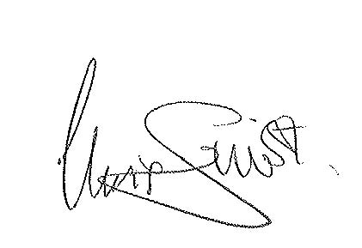
This ASR has been approved by:
Endorsed By: Chris Sinnott, Chief Executive Chorley Council
Signature:

Endorsed By: Jennifer Mullin, Director of Communities
Signature: 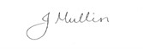
This ASR has not been signed off by a Director of Public Health.
If you have any comments on this ASR, please send them to Chorley Council at:
Civic Offices
Union Street
Chorley
Lancashire
PR7 1AL
01257 515151
contact@chorley.gov.uk

Table of Contents
Executive Summary: Air Quality in Our Area i
Air Quality in Chorley i
Actions to Improve Air Quality ii
Conclusions and Priorities iv
Local Engagement and How to get Involved iv
Local Responsibilities and Commitment vii
1 Local Air Quality Management 1
2 Actions to Improve Air Quality 2
2.1 Air Quality Management Areas 2
2.2 Progress and Impact of Measures to address Air Quality in Chorley 3
2.3 PM_{2.5} – Local Authority Approach to Reducing Emissions and/or Concentrations 8
3 Air Quality Monitoring Data and Comparison with Air Quality Objectives and National Compliance 10
3.1 Summary of Monitoring Undertaken 10
3.1.1 Automatic Monitoring Sites 10
3.1.2 Non-Automatic Monitoring Sites 10
3.2 Individual Pollutants 10
3.2.1 Nitrogen Dioxide (NO₂) 11
3.2.2 Particulate Matter (PM₁₀) 11
3.2.3 Particulate Matter (PM_{2.5}) 11
3.2.4 Sulphur Dioxide (SO₂) 12
Appendix A: Monitoring Results 13
Appendix B: Full Monthly Diffusion Tube Results for 2022 23
Appendix C: Supporting Technical Information / Air Quality Monitoring Data QA/QC 26
New or Changed Sources Identified Within Chorley Council During 2022 26
Additional Air Quality Works Undertaken by Chorley Council During 2022 26
QA/QC of Diffusion Tube Monitoring 27
Diffusion Tube Annualisation 29
Diffusion Tube Bias Adjustment Factors 30
NO₂ Fall-off with Distance from the Road 31
Appendix D: Map(s) of Monitoring Locations and AQMAs 32
Appendix E: Summary of Air Quality Objectives in England 34
Glossary of Terms 35
References 36

Figures
Figure A.1 – Trends in Annual Mean NO₂ Concentrations Across Chorley North Sampling Sites 21
Figure A.2 – Trends in Annual Mean NO₂ Concentrations Across Chorley South Sampling Sites 22

Figure D.1 – Map of Non-Automatic Monitoring Sites Chorley North 32
Figure D.2 – Map of Non-Automatic Monitoring Sites Chorley South 33
Tables
Table 2.1 – Progress on Measures to Improve Air Quality 6

Table A.1 – Details of Non-Automatic Monitoring Sites 13
Table A.2 – Annual Mean NO₂ Monitoring Results: Non-Automatic Monitoring (µg/m³) 17

Table B.1 – NO₂ 2022 Diffusion Tube Results (µg/m³) 23

Table C.1 - Laboratory summary performance for AIR Nitrogen Dioxide PT rounds, 2019-2021 28
Table C.2 - Summary of Precision Results for Nitrogen Dioxide Diffusion Tube Collocation Studies by Laboratory, 2019-2021 29
Table C.3 – Annualisation Summary (concentrations presented in µg/m³) 30
Table C.4 – Bias Adjustment Factor 30

Table E.1 – Air Quality Objectives in England 34

Local Air Quality Management
This report provides an overview of air quality in Chorley during 2022. It fulfils the requirements of Local Air Quality Management (LAQM) as set out in Part IV of the Environment Act (1995), as amended by the Environment Act (2021), and the relevant Policy and Technical Guidance documents.
The LAQM process places an obligation on all local authorities to regularly review and assess air quality in their areas, and to determine whether or not the air quality objectives are likely to be achieved. Where an exceedance is considered likely the local authority must declare an Air Quality Management Area (AQMA) and prepare an Air Quality Action Plan (AQAP) setting out the measures it intends to put in place in order to achieve and maintain the objectives and the dates by which each measure will be carried out. This Annual Status Report (ASR) is an annual requirement showing the strategies employed by Chorley Council to improve air quality and any progress that has been made.
The statutory air quality objectives applicable to LAQM in England are presented in Table E.1.

Actions to Improve Air Quality

Air Quality Management Areas
Air Quality Management Areas (AQMAs) are declared when there is an exceedance or likely exceedance of an air quality objective. After declaration, the authority should prepare an Air Quality Action Plan (AQAP) within 18 months. The AQAP should specify how air quality targets will be achieved and maintained, and provide dates by which measures will be carried out.
Chorley Council currently does not have any declared AQMAs. A local Air Quality Strategy is in place to prevent and reduce polluting activities. The Local Air Quality Strategy is available on the Council’s website, using this link to the Chorley Air Quality webpage.

Progress and Impact of Measures to address Air Quality in Chorley
Defra’s appraisal of last year’s ASR concluded the report was well structured, detailed, and provides the information specified in the Guidance. Chorley Council is grateful for the feedback received and has noted the following comments which were provided to help inform future reports:
- The Council has included a comprehensive discussion and review of its monitoring strategy, informed by the results of monitoring network from previous reporting years. This demonstrates the Council’s proactive and dedicated approach to improving air quality across the area.
- It is encouraging to see the Council considered the comments made during the previous appraisal and actively made an effort to address all of these actions for this year’s ASR.
- Extensive Trend graphs have been provided for all monitoring data, which is commended.
- The council has correctly undertaken distance correction calculations for the one site which recorded an annual mean NO2 concentration >36 µg/m3. This is commended.
- There is one minor formatting error in “Section: 3.2.1 Nitrogen Dioxide (NO2)” of the report. The report states “There are no exceedances of the air quality objectives, either by the annual mean concentrations of 40µg/m3 or any tube result exceeding 60µg/m3, which indicates that an exceedance of the 1-hour mean objective is likely.” For future cases, where there are no exceedances of the air quality objectives, the report should say “There are no exceedances of the air quality objectives, either by the annual mean concentrations of 40µg/m3 or any tube result exceeding 60µg/m3, which indicates that an exceedance of the 1-hour mean objective is unlikely.” The Council is encouraged to correct this inconsistency in future reports submitted.
- The Council has provided a comprehensive list of key actions which they are planning to undertake to improve air quality over the next reporting year. This is commended.
- The Council is commended for their approach to further improving Air Quality in the absence of a formal AQAP. Continued local engagement through various means including additional public consultations on key measures is highly encouraged.
- The Council is encouraged to update the References section in the Appendix. Several references mentioned in the report are missing from the Appendix- primarily from the “Local Engagement and How to get Involved” section from the Executive summary.

Chorley Council has taken on-board the comments from the previous ASR submission and has taken forward several direct measures during the current reporting year of 2022 in pursuit of improving local air quality.
Details of all measures completed, in progress or planned are set out in Table 2.1. 13 measures are included within Table 2.1, with the type of measure and the progress Chorley Council have made during the reporting year of 2022 presented. Where there have been, or continue to be, barriers restricting the implementation of the measure, these are also presented within Table 2.1.
More detail on these measures can be found in their respective Action Plans: Clean Air Strategy and Climate Change Strategy. Key completed measures are:
- Introduction of Air Quality Strategy and Climate Change Strategy to detail Chorley Council’s activities and goals.
- Promote flexible and homeworking to reduce commuting and avoidable travel, policy now implemented across the Council.
Chorley Council expects the following measures to be completed over the course of the next reporting year in order to reduce emissions, increase awareness and promote sustainable travel:
- Develop an engagement strategy to support the air quality agenda across the Borough.
- Improved access to Electric vehicles Charging options – pending feasibility study and funding.
Chorley Council’s priorities for the coming year are continuing to support Local Plan development, work to promote active travel alternatives and electric vehicles and developing public outreach work for air quality.
Chorley Council worked to implement these measures in partnership with the following stakeholders during 2022:
- Neighbouring local authorities
- The Highways Authority
The principal challenges and barriers to implementation that Chorley Council anticipates facing are lack of resources both internally and from partner organisations.
Progress on the following measures has been slower than expected due to:
- Local Plan Development – has been affected by challenges encountered by the relevant team.
- Trial use of hydrogenated vegetable oil (HVO) fuel throughout Council fleet – Trialled on one bin lorry but now indefinitely paused due to rising cost of HVO, pending evaluation of availability and sustainability of material.
- Air Quality Planning Guidance – Not currently progressing at County level.
Chorley Council anticipates that the measures stated above and in Table 2.1 will maintain compliance with national air quality objectives

Table 2.1 – Progress on Measures to Improve Air Quality
Measure No. | Measure | Category | Classification | Year Measure Introduced in AQAP | Estimated / Actual Completion Date | Organisations Involved | Funding Source | Defra AQ Grant Funding | Funding Status | Estimated Cost of Measure | Measure Status | Reduction in Pollutant / Emission from Measure | Key Performance Indicator | Progress to Date | Comments / Barriers to Implementation
1 | Air Quality Planning Guidance | Policy Guidance and Development Control | Regional Groups Co-ordinating programmes to develop Area wide Strategies to reduce emissions and improve air quality | 2020 | 2022 | Lancashire LA's | Existing Budgets | NO | Not Funded | < £10k | Aborted | Reduced Emissions | Implementation | Work paused. | Limited buy in from DC’s. Progressing separately via Central Lancashire local plan.
2 | Local Plan Development | Policy Guidance and Development Control | Regional Groups Co-ordinating programmes to develop Area wide Strategies to reduce emissions and improve air quality | 2020 | 2024 | Preston City Council, South Ribble Borough Council and Chorley Council | Existing Budgets | NO | Partially Funded | £50k - £100k | Implementation | Reduced Emissions | Inclusion within the Central Lancs Plan | Central Lancs Local Plan progressing across the 3 LA's with Part  One preferred  Options consultation complete. Work being taken forward. | First phase successful, second phase on-going Developers’ reluctance to implement planning policy guidance. Timescale extended to external factors affecting progress by Local Plan Team.
3 | Introduction of Air Quality and Climate Change Strategy | Policy Guidance and Development Control | Air Quality Planning and Policy Guidance | 2020 | 2022 | Chorley Council | Existing Budgets | NO | Not Funded | < £10k | Completed | Reduced Emissions | Adoption of air quality and climate change strategy | Held public consultation and refreshed website. Individual action planning under development. | Focus of the Strategies will be to promote and support behavioural change and sustainable development.
4 | Plan to progress the Council's conversion to electric vehicles | Promoting Low Emission Transport | Public Vehicle Procurement -Prioritising uptake of low emission vehicles | 2020 | 2024 | Chorley Council | Existing Budgets | NO | Partially Funded | £500k - £1 million | Planning | Reduced Emissions | Implementation | Develop a plan to progress the Council’s conversion to  electric vehicles. Some electric vans purchased and in-use. | Cost of EV vehicles. Needs assessment of suitability for intended use.
5 | Develop an engagement strategy to support the AQ agenda across the Borough | Public Information | Other | 2022 | 2023 | Chorley Council | Existing Budgets | NO | Not Funded | < £10k | Implementation | Reduced Emissions | Implementation | Produced calendar of AQ activities, e.g. ASR publication, “Clean Air Day” and “Ready to Burn” campaigns for council social media channels.  Produced learning events for Councillors. | Resistance from residents and businesses. Concerns over conflict with Cost of Living. New legislation and Guidance from Central Government needed.
6 | Promote flexible and homeworking to reduce commuting and avoidable travel | Promoting Travel Alternatives | Encourage / Facilitate homeworking | 2021 | 2022 | Chorley Council | Existing Budgets | NO | Not Funded | < £10k | Completed | Reduced staff travel | Implementation | Adopted a hybrid-working charter, incorporated into business plan by service leads. | Public accessibility to Council services and staff. Availability of homeworking equipment.
7 | Improved access to Electric vehicles Charging options | Promoting Low Emission Transport | Procuring alternative Refuelling infrastructure to promote Low Emission Vehicles, EV recharging, Gas fuel recharging | 2021 | 2023 | Chorley Council | Existing Budgets + External Grants | NO | Partially Funded | £10k - 50k | Implementation | Reduced Emissions | Reliable EV charging network across Borough | Review car park charging policy relating to EV’s and consult with public to incentivise alternative travel. | Cost of EV vehicles. Availability of space for EV charging points.
8 | Cycle parking, repair and changing facilities | Promoting Travel Alternatives | Promotion of cycling | 2022 | 2024 | Chorley Council | Existing Budgets + External Grants | NO | Partially Funded | < £10k | Planning | Reduced Emissions | Implementation | Developing plans following completed active travel consultation. | Funding and identifying suitable locations. Resistance from residents and businesses.
9 | Trial use of hydrogenated vegetable oil  (HVO) fuel throughout  Council fleet | Freight and Delivery Management | Other | 2022 | 2024 | Chorley Council | Existing Budgets | NO | Partially Funded | < £10k | Planning | Reduced Emissions | Completed review | Initial trial carried out on a bin lorry. Trial now on indefinite pause due to rising cost of HVO and evaluation of availability and sustainability of material. | Cost of HVO. Performance in standard diesel engines. Maintenance costs. Sustainability of the fuel.
10 | Bonfires and dark smoke offences | Public Information | Other | 2022 | 2024 | Chorley Council | Existing Budgets | NO | Not Funded | < £10k | Planning | Reduced Emissions | Implementation | Assessing implication of Environment Act on enforcement. Creating internal training document and guidance for Environmental Health Officers. | Resistance from residents and businesses. Concerns over conflict with Cost of Living.
11 | Health based campaigns | Public Information | Other | 2022 | 2024 | Chorley Council | Existing Budgets | NO | Not Funded | < £10k | Planning | Reduced Emissions | Implementation | Developing strategy across Council involving Health Protection and Communications officers. | Resistance from residents and businesses. Concerns over conflict with Cost of Living.
12 | Potential for business Ecargo bikes. | Freight and Delivery Management | Freight Partnerships for city centre deliveries | 2023 | 2025 | Chorley Council | Existing Budgets | NO | Not Funded | < £10k | Planning | Reduced Emissions | Ecargo bike(s) in use | Currently undertaking preliminary feasibility study to replace some council vehicle movements with Ecargo bikes. | Resistance from residents and businesses. Unsuitable for proposed tasks.
13 | Lancashire Local Cycling and Walking Infrastructure Plan | Promoting Travel Alternatives | Other | 2022 | 2024 | Lancashire LA's | Existing Budgets | NO | Not Funded | < £10k | Planning | Reduced Emissions | Implementation of plan by Lancashire County Council | Chorley have provided comments and resident views on draft plan to ensure representation. | Funding and identifying suitable locations. Resistance from residents and businesses. Priorities of LCC Highways Authority.

PM_{2.5} – Local Authority Approach to Reducing Emissions and/or Concentrations
As detailed in Policy Guidance LAQM.PG22 (Chapter 8), local authorities are expected to work towards reducing emissions and/or concentrations of PM_{2.5} (particulate matter with an aerodynamic diameter of 2.5µm or less). There is clear evidence that PM_{2.5} has a significant impact on human health, including premature mortality, allergic reactions, and cardiovascular diseases.
Chorley Council is taking the following measures which will either address PM_{2.5} directly or as a co-benefit of other measures:
- DEFRA background maps for 2022 suggest PM_{2.5} concentrations of 6-8 µg.m⁻³ across the Borough, of which ~53% is from secondary sources, ~31% residual and salt sources, ~8% from domestic heating, ~4% from industry, ~2% from transport sources and ~2% point sources.
- Chorley Council are continuing the trial roll-out of monitoring using EarthSense Zephyr continuous automatic particulate monitors at three locations across the borough. Though this system is not approved for inclusion in the ASR or certified using the Environment Agency’s Indicative instrument certification scheme, the data collected is providing qualitative data on the scale of the issue, particulate pollution trends and a benchmark against which to measure progress.
- Chorley’s Health Protection Officer has undertaken some preliminary research on the local health context of PM_{2.5} on residents. Calculations based on 2015-2017 data suggest that the 'premature mortality' rate in Chorley Borough attributable to all particulate matter is 13.5 per 100,000 population. This compares to 13.9 in Lancashire-12, and 16.9 in England. It was not possible to identify more detailed local correlations due to confounding factors or lack of data broken-down to ward level.
- Of the transport sources, the motorway network is currently a large source of PM pollution. The exposure from the M6, M61 and M61 will likely reduce in-line with national targets and standards for vehicles.
- Chorley Council engages with the UK government on this issue and provided a response to the draft Air Quality Strategy Consultation in April 2023.
- Continued implementation of the Clean Air and Climate Change Strategies which contains actions that have co-benefits for reducing PM_{2.5} (e.g. decarbonisation of heating and development of local EV strategy).
- The council is currently assessing the impact of the Environment Act 2021 on smoke control and enforcement. This involves identifying knowledge gaps and training for Environmental Health Officers on Smoke Control Areas, bonfires, and dark smoke offences.
- Chorley promotes national campaigns such as “Ready to Burn”, DEFRA’s “Burn Better” and “Burnright”.
- Developing a public engagement strategy to support the air quality agenda across the Borough to raise awareness with residents on how to make better choices to prevent PM_{2.5} (e.g. reducing solid fuel burning, choosing active travel options etc.). This includes health-based campaigns.
- Promoting flexible and homeworking to reduce commuting and avoidable travel.
- Investing in provision of attractive and secure cycle parking to reduce personal car use.
- Proactively inputting into Lancashire Local Cycling and Walking Infrastructure Plan to increase attractiveness and safety of walking, cycling, and wheeling.
- Working in conjunction with neighbouring local authorities on introducing a Public Spaces Protection Order to prevent West Pennine Moorland fires.
- Chorley Council acknowledge that there are some concerns regarding increased PM_{2.5} emissions from the tyre and brake dust of Electric Vehicles and alternative fuels, though there are beneficial reductions in NO_{x} and CO₂. This is under constant review and responsive to national guidance.

Air Quality Monitoring Data and Comparison with Air Quality Objectives and National Compliance
This section sets out the monitoring undertaken within 2022 by Chorley Council and how it compares with the relevant air quality objectives. In addition, monitoring results are presented for a five-year period between 2018 and 2022 to allow monitoring trends to be identified and discussed.

Summary of Monitoring Undertaken

Automatic Monitoring Sites
Chorley Council does not currently have any automatic monitoring sites.
Chorley Council continues to trial qualitative automatic (continuous) monitoring for PM at three sites (located at CH05, CH51 and CH59). The system under trial uses Zephyr continuous air quality monitors provided by EarthSense Systems Limited. The data collected from these monitors are not approved for inclusion in the ASR or certified using the Environment Agency’s Indicative instrument certification scheme and therefore not able to be included in the ASR.

Non-Automatic Monitoring Sites
Chorley Council undertook non- automatic (i.e. passive) monitoring of NO₂ at 43 sites during 2022. Table A.1 in Appendix A presents the details of the non-automatic sites.
Maps showing the location of the monitoring sites are provided in Appendix D. Further details on Quality Assurance/Quality Control (QA/QC) for the diffusion tubes, including bias adjustments and any other adjustments applied (e.g. annualisation and/or distance correction), are included in Appendix C.

Individual Pollutants
The air quality monitoring results presented in this section are, where relevant, adjusted for bias, annualisation (where the annual mean data capture is below 75% and greater than 25%), and distance correction. Further details on adjustments are provided in Appendix C.

Nitrogen Dioxide (NO₂)
Table A.2 in Appendix A compare the ratified and adjusted monitored NO₂ annual mean concentrations for the past five years with the air quality objective of 40µg/m³. Note that the concentration data presented represents the concentration at the location of the monitoring site, following the application of bias adjustment and annualisation, as required (i.e. the values are exclusive of any consideration to fall-off with distance adjustment).
For diffusion tubes, the full 2022 dataset of monthly mean values is provided in Appendix B. Note that the concentration data presented in Table B.1 includes distance corrected values, only where relevant.
Table A.5 in Appendix A compares the ratified continuous monitored NO₂ hourly mean concentrations for the past five years with the air quality objective of 200µg/m³, not to be exceeded more than 18 times per year.
There are no exceedances of the air quality objectives, either by the annual mean concentrations of 40µg/m³ or any tube result exceeding 60µg/m³, which indicates that an exceedance of the 1-hour mean objective is unlikely.

Particulate Matter (PM₁₀)
Chorley Council does not currently monitor PM₁₀ or PM_{2.5} levels. However, a check of the Defra background maps indicates no likely exceedances of the objective levels for either of these two pollutants.
Chorley Council continues to monitor PM10 or PM2.5 levels as part of the Zephyr continuous air quality monitor trial. The data collected from these monitors is indicative and therefore is not able to be included in the ASR. However, the readings will support our on-going work regarding PM pollution across the Borough.

Particulate Matter (PM_{2.5})
Chorley Council does not currently monitor PM₁₀ or PM_{2.5} levels. However, a check of the Defra background maps indicates no likely exceedances of the objective levels for either of these two pollutants.
Chorley Council continues to monitor PM10 or PM2.5 levels as part of the Zephyr continuous air quality monitor trial. The data collected from these monitors is indicative and therefore is not able to be included in the ASR. However, the readings will support our on-going work regarding PM pollution across the Borough.

Sulphur Dioxide (SO₂)
Chorley Council does not monitor SO₂ levels, a check of the Defra background maps indicates that there are no likely exceedances of the objective levels for this pollutant.

Appendix A: Monitoring Results
Table A.1 – Details of Non-Automatic Monitoring Sites
Diffusion Tube ID | Site Name | Site Type | X OS Grid Ref (Easting) | Y OS Grid Ref (Northing) | Pollutants Monitored | In AQMA? Which AQMA? | Distance to Relevant Exposure (m) ⁽¹⁾ | Distance to kerb of nearest road (m) ⁽²⁾ | Tube Co-located with a Continuous Analyser? | Tube Height (m)
CH35 | St Thomas Road | Roadside | 358145 | 417645 | NO2 | No | 3.0 | 3.2 | No | 2.5
CH23 | Market St, Chorley | Roadside | 358357 | 417297 | NO2 | No | 1.5 | 2.5 | No | 2.5
CH25 | Bolton Street | Roadside | 358518 | 417072 | NO2 | No | 0.5 | 1.8 | No | 2.5
CH36 | Bolton Road | Roadside | 358714 | 416839 | NO2 | No | 0.4 | 2.0 | No | 2.5
CH37 | Bolton Road | Roadside | 358830 | 416726 | NO2 | No | 0.0 | 2.2 | No | 2.5
CH38 | Bolton Road | Roadside | 359060 | 416468 | NO2 | No | 0.0 | 2.9 | No | 2.5
CH39 | Duxbury Manor Gardens | Roadside | 358933 | 415862 | NO2 | No | 0.0 | 13.0 | No | 2.5
CH05 | Market St, Adlington | Kerbside | 360095 | 413089 | NO2 | No | 2.5 | 0.5 | No | 2.5
CH40 | Devonshire Road | Roadside | 358092 | 416925 | NO2 | No | 0.0 | 2.3 | No | 2.5
CH41 | Moor Road | Roadside | 357387 | 416123 | NO2 | No | 0.0 | 3.0 | No | 2.5
CH06 | Moor Road | Kerbside | 357436 | 416130 | NO2 | No | 8.5 | 0.5 | No | 2.5
CH42 | Spendmore Lane – Coppull | Roadside | 356547 | 414525 | NO2 | No | 0.0 | 5.5 | No | 2.5
CH43 | Spendmore lane – Coppull | Roadside | 356339 | 414150 | NO2 | No | 0.0 | 2.5 | No | 2.5
CH44 | Spendmore lane – Coppull | Roadside | 356039 | 414054 | NO2 | No | 0.0 | 1.5 | No | 2.5
CH45 | Preston Road Coppull | Roadside | 355534 | 413755 | NO2 | No | 3.5 | 5.0 | No | 2.5
CH46 | A49 Wigan Road South | Roadside | 355540 | 418309 | NO2 | No | 7.5 | 2.0 | No | 2.5
CH08 | Balshaw Lane | Roadside | 355891 | 418467 | NO2 | No | 11.0 | 2.0 | No | 2.5
CH11 | A49 Wigan Road South, Euxton Ln | Kerbside | 355454 | 419317 | NO2 | No | 1.5 | 0.5 | No | 2.5
CH47 | Buckshaw Avenue | Roadside | 356464 | 420218 | NO2 | No | 4.5 | 2.0 | No | 2.5
CH48 | Buckshaw Avenue | Roadside | 356485 | 420262 | NO2 | No | 0.0 | 3.0 | No | 2.5
CH49 | Buckshaw Avenue | Roadside | 356613 | 420245 | NO2 | No | 0.0 | 11.0 | No | 2.5
CH50 | M6, Moss Lane | Roadside | 355400 | 422696 | NO2 | No | 0.0 | 17.5 | No | 2.5
CH51 | A49 Wigan Road - Lancaster Lane | Roadside | 355697 | 422432 | NO2 | No | 3.8 | 2.0 | No | 2.5
CH52 | A6 Preston Road – near M65 | Roadside | 357335 | 424499 | NO2 | No | 0.0 | 5.5 | No | 2.5
CH53 | A6 Preston Road | Roadside | 357902 | 423586 | NO2 | No | 5.0 | 1.0 | No | 2.5
CH32 | M61, Ashdown | Roadside | 358313 | 422937 | NO2 | No | 5.5 | 0.9 | No | 2.5
CH31 | A6 Preston Road Clayton | Roadside | 357879 | 423303 | NO2 | No | 1.2 | 2.9 | No | 2.5
CH17 | A6 Preston Rd, Whittle | Kerbside | 357936 | 422176 | NO2 | No | 0.5 | 4.0 | No | 2.5
CH17A | A6 Preston Rd, Whittle | Roadside | 357885 | 421524 | NO2 | No | 7.0 | 1.5 | No | 2.5
CH33 | A6 Preston Road Whittle | Kerbside | 358110 | 420361 | NO2 | No | 2.4 | 1.4 | No | 2.5
CH34 | M61, Fallow Close | Kerbside | 358568 | 420246 | NO2 | No | 3.3 | 0.5 | No | 2.5
CH54 | A6 Preston Road | Roadside | 358193 | 419909 | NO2 | No | 0.0 | 8.4 | No | 2.5
CH55 | Blackburn Road | Roadside | 359415 | 419740 | NO2 | No | 0.0 | 11.5 | No | 2.5
CH56 | BOTANY BAY – Millennium way | Roadside | 359110 | 419646 | NO2 | No | 320.0 | 2.0 | No | 2.5
CH57 | BOTANY BAY – Entrance | Roadside | 359019 | 419651 | NO2 | No | 320.0 | 2.0 | No | 2.5
CH19 | A6, Chorley Hospital | Roadside | 358335 | 419226 | NO2 | No | 10.0 | 4.0 | No | 2.5
CH24 | Euxton Lane, Hospital | Roadside | 358023 | 419151 | NO2 | No | 1.0 | 1.5 | No | 2.5
CH20 | A6 South Chorley Hospital | Roadside | 358325 | 418987 | NO2 | No | 13.0 | 1.0 | No | 2.5
CH58 | A6 Preston Road | Roadside | 358399 | 418579 | NO2 | No | 30.0 | 1.0 | No | 2.5
CH59 | A6 Preston Road | Roadside | 358448 | 418540 | NO2 | No | 0.0 | 3.0 | No | 2.5
CH60 | Water Street | Kerbside | 358541 | 417816 | NO2 | No | 2.0 | 0.5 | No | 2.5
CH61 | Water Street | Roadside | 358526 | 417847 | NO2 | No | 1.0 | 1.0 | No | 2.5
CH62 | Water Street | Roadside | 358566 | 418400 | NO2 | No | 6.0 | 1.0 | No | 2.5
Notes:
(1) 0m if the monitoring site is at a location of exposure (e.g. installed on the façade of a residential property).
(2) N/A if not applicable.
Table A.2 – Annual Mean NO₂ Monitoring Results: Non-Automatic Monitoring (µg/m³)
Diffusion Tube ID | X OS Grid Ref (Easting) | Y OS Grid Ref (Northing) | Site Type | Valid Data Capture for Monitoring Period (%) ⁽¹⁾ | Valid Data Capture 2022 (%) ⁽²⁾ | 2018 | 2019 | 2020 | 2021 | 2022
CH35 | 358145 | 417645 | Roadside | 99.2 | 99.2 |  |  |  | 21.6 | 18.1
CH23 | 358357 | 417297 | Roadside | 99.2 | 99.2 | 30.9 | 32.8 | 23.3 | 25.7 | 24.1
CH25 | 358518 | 417072 | Roadside | 81.9 | 81.9 | 25.8 | 25.7 | 26.2 | 20.8 | 18.0
CH36 | 358714 | 416839 | Roadside | 99.2 | 99.2 |  |  |  | 32.3 | 28.3
CH37 | 358830 | 416726 | Roadside | 99.2 | 99.2 |  |  |  | 28.1 | 23.4
CH38 | 359060 | 416468 | Roadside | 99.2 | 99.2 |  |  |  | 19.5 | 17.0
CH39 | 358933 | 415862 | Roadside | 99.2 | 99.2 |  |  |  | 11.3 | 10.1
CH05 | 360095 | 413089 | Kerbside | 99.2 | 99.2 | 34.1 | 32.2 | 23.4 | 24.8 | 22.8
CH40 | 358092 | 416925 | Roadside | 75.0 | 75.0 |  |  |  | 13.8 | 12.1
CH41 | 357387 | 416123 | Roadside | 99.2 | 99.2 |  |  |  | 23.5 | 18.0
CH06 | 357436 | 416130 | Kerbside | 99.2 | 99.2 | 28.0 | 27.1 | 22.0 | 21.9 | 19.4
CH42 | 356547 | 414525 | Roadside | 99.2 | 99.2 |  |  |  | 17.3 | 14.5
CH43 | 356339 | 414150 | Roadside | 99.2 | 99.2 |  |  |  | 20.3 | 18.1
CH44 | 356039 | 414054 | Roadside | 99.2 | 99.2 |  |  |  | 24.5 | 19.4
CH45 | 355534 | 413755 | Roadside | 91.5 | 91.5 |  |  |  | 23.8 | 19.5
CH46 | 355540 | 418309 | Roadside | 99.2 | 99.2 |  |  |  | 27.6 | 22.6
CH08 | 355891 | 418467 | Roadside | 99.2 | 99.2 | 29.3 | 29.0 | 21.6 | 23.4 | 20.5
CH11 | 355454 | 419317 | Kerbside | 99.2 | 99.2 | 26.6 | 24.2 | 19.5 | 21.5 | 18.9
CH47 | 356464 | 420218 | Roadside | 99.2 | 99.2 |  |  |  | 17.8 | 16.7
CH48 | 356485 | 420262 | Roadside | 99.2 | 99.2 |  |  |  | 17.8 | 15.5
CH49 | 356613 | 420245 | Roadside | 99.2 | 99.2 |  |  |  | 18.5 | 16.8
CH50 | 355400 | 422696 | Roadside | 99.2 | 99.2 |  |  |  | 21.9 | 19.5
CH51 | 355697 | 422432 | Roadside | 99.2 | 99.2 |  |  |  | 27.1 | 22.2
CH52 | 357335 | 424499 | Roadside | 99.2 | 99.2 |  |  |  | 17.7 | 16.0
CH53 | 357902 | 423586 | Roadside | 99.2 | 99.2 |  |  |  | 29.7 | 24.0
CH32 | 358313 | 422937 | Roadside | 99.2 | 99.2 |  |  | 17.2 | 18.7 | 17.1
CH31 | 357879 | 423303 | Roadside | 99.2 | 99.2 |  |  | 16.9 | 18.7 | 17.8
CH17 | 357936 | 422176 | Kerbside | 99.2 | 99.2 |  |  |  | 23.9 | 19.9
CH17A | 357885 | 421524 | Roadside | 76.1 | 76.1 | 28.0 | 27.0 | 20.3 | 20.5 | 19.5
CH33 | 358110 | 420361 | Kerbside | 89.6 | 89.6 |  |  | 19.6 | 21.0 | 19.0
CH34 | 358568 | 420246 | Kerbside | 99.2 | 99.2 |  |  | 18.6 | 20.1 | 17.9
CH54 | 358193 | 419909 | Roadside | 74.2 | 74.2 |  |  |  | 18.4 | 18.0
CH55 | 359415 | 419740 | Roadside | 91.5 | 91.5 |  |  |  | 15.8 | 14.7
CH56 | 359110 | 419646 | Roadside | 99.2 | 99.2 |  |  |  | 23.8 | 18.6
CH57 | 359019 | 419651 | Roadside | 57.7 | 57.7 |  |  |  | 15.7 | 13.4
CH19 | 358335 | 419226 | Roadside | 91.5 | 91.5 | 31.1 | 30.4 | 21.1 | 22.2 | 20.2
CH24 | 358023 | 419151 | Roadside | 99.2 | 99.2 | 34.9 | 31.4 | 23.7 | 26.7 | 24.4
CH20 | 358325 | 418987 | Roadside | 99.2 | 99.2 | 31.7 | 30.2 | 22.7 | 24.4 | 21.5
CH58 | 358399 | 418579 | Roadside | 99.2 | 99.2 |  |  |  | 33.3 | 26.0
CH59 | 358448 | 418540 | Roadside | 91.5 | 91.5 |  |  |  | 24.6 | 22.6
CH60 | 358541 | 417816 | Kerbside | 99.2 | 99.2 |  |  |  | 37.6 | 34.1
CH61 | 358526 | 417847 | Roadside | 99.2 | 99.2 |  |  |  | 32.1 | 30.2
CH62 | 358566 | 418400 | Roadside | 99.2 | 99.2 |  |  |  | 30.2 | 25.5
☒ Annualisation has been conducted where data capture is <75% and >25% in line with LAQM.TG22
☒ Diffusion tube data has been bias adjusted
☒ Reported concentrations are those at the location of the monitoring site (bias adjusted and annualised, as required), i.e. prior to any fall-off with distance correction
Notes:
The annual mean concentrations are presented as µg/m³.
Exceedances of the NO₂ annual mean objective of 40µg/m³ are shown in bold.
NO₂ annual means exceeding 60µg/m³, indicating a potential exceedance of the NO₂ 1-hour mean objective are shown in bold and underlined.
Means for diffusion tubes have been corrected for bias. All means have been “annualised” as per LAQM.TG22 if valid data capture for the full calendar year is less than 75%. See Appendix C for details.
Concentrations are those at the location of monitoring and not those following any fall-off with distance adjustment.
(1) Data capture for the monitoring period, in cases where monitoring was only carried out for part of the year.
(2) Data capture for the full calendar year (e.g. if monitoring was carried out for 6 months, the maximum data capture for the full calendar year is 50%).
Figure A.1 – Trends in Annual Mean NO₂ Concentrations Across Chorley North Sampling Sites
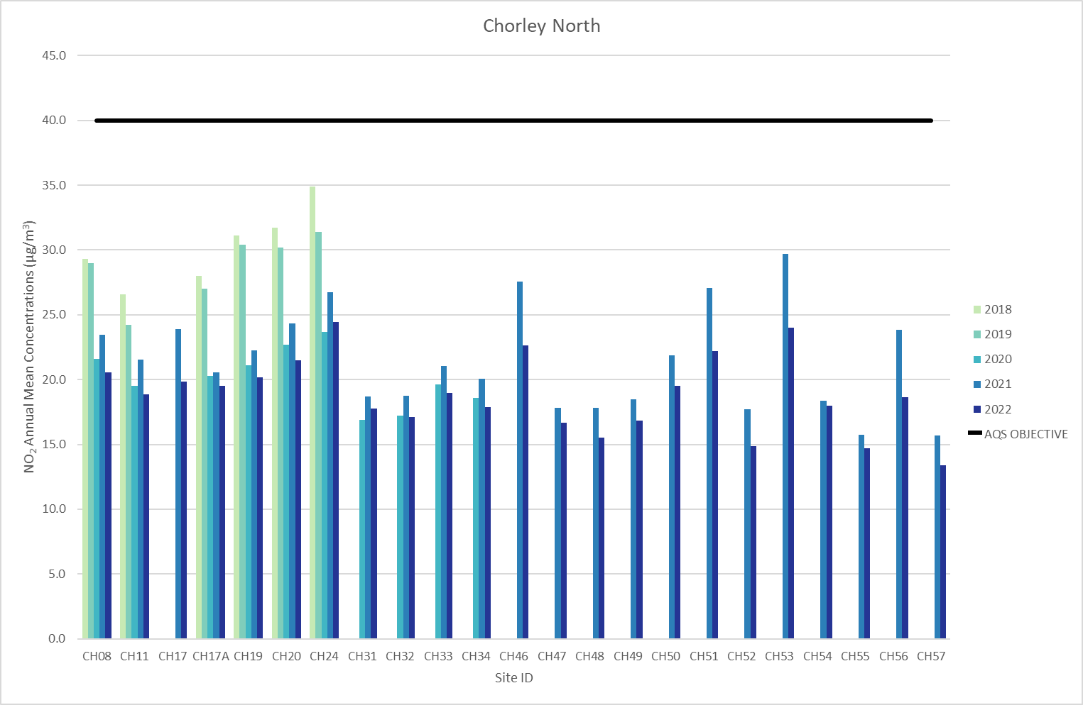
Figure A.2 – Trends in Annual Mean NO₂ Concentrations Across Chorley South Sampling Sites
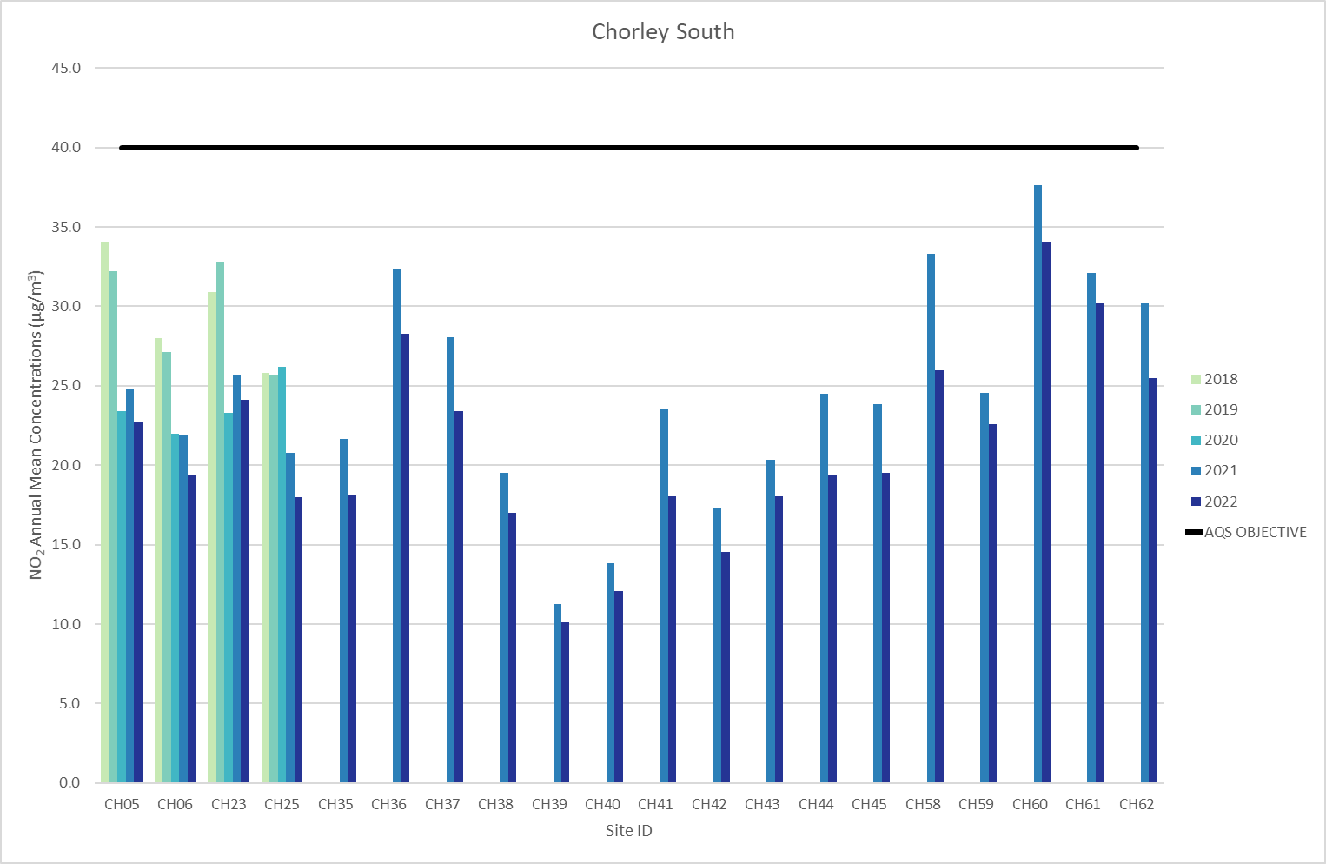

Appendix B: Full Monthly Diffusion Tube Results for 2022
Table B.1 – NO₂ 2022 Diffusion Tube Results (µg/m³)
Diffusion Tube ID | X OS Grid Ref (Easting) | Y OS Grid Ref (Northing) | NO₂ Mean Concentrations (µg/m³) |  |  |  |  |  |  |  |  |  |  |  | Time Weighted Annual Mean (µg/m3) |  |  | Comment
 |  |  | Jan | Feb | Mar | Apr | May | Jun | Jul | Aug | Sep | Oct | Nov | Dec
 |  |  |  |  |  |  |  |  |  |  |  |  |  |  | Raw Data | Bias Adjusted (0.83) and Annualised | Distance Corrected to Nearest Exposure
CH35 | 358145 | 417645 | 32.9 | 20.4 | 28.2 | 21.1 | 15.4 | 16.8 | 17.8 | 19.9 |  | 23.2 |  | 22.5 | 21.8 | 18.1
CH23 | 358357 | 417297 | 37.8 | 23.9 | 38.0 | 23.9 | 20.2 | 20.8 | 24.2 | 24.5 |  | 31.0 |  | 37.8 | 29.1 | 24.1
CH25 | 358518 | 417072 | 33.6 | 16.2 | 30.1 | 22.0 | 14.3 | 15.9 | 18.0 | 20.9 |  | 23.5 |  |  | 21.7 | 18.0
CH36 | 358714 | 416839 | 49.7 | 37.1 | 36.9 | 31.6 | 32.4 | 32.0 | 33.8 | 28.4 |  | 35.1 |  | 30.7 | 34.1 | 28.3
CH37 | 358830 | 416726 | 44.4 | 28.5 | 33.9 | 26.7 | 23.2 | 23.7 | 26.8 | 23.6 |  | 27.8 |  | 27.2 | 28.2 | 23.4
CH38 | 359060 | 416468 | 29.7 | 15.9 | 28.1 | 20.6 | 13.6 | 16.5 | 16.2 | 19.4 |  | 20.8 |  | 22.4 | 20.5 | 17.0
CH39 | 358933 | 415862 | 20.6 | 10.0 | 19.0 | 10.7 | 5.7 | 8.1 | 8.8 | 9.9 |  | 12.5 |  | 14.7 | 12.2 | 10.1
CH05 | 360095 | 413089 | 40.8 | 22.1 | 37.2 | 23.3 | 22.9 | 23.6 | 24.9 | 25.2 |  | 28.1 |  | 27.8 | 27.4 | 22.8
CH40 | 358092 | 416925 | 26.1 | 12.5 | 19.9 |  |  |  | 10.4 | 12.0 |  | 15.2 |  | 17.3 | 15.9 | 12.1
CH41 | 357387 | 416123 | 33.9 | 20.6 | 26.9 | 22.1 | 16.7 | 17.1 | 17.8 | 20.3 |  | 20.8 |  | 22.2 | 21.7 | 18.0
CH06 | 357436 | 416130 | 36.7 | 23.4 | 28.6 | 21.5 | 19.3 | 19.4 | 19.6 | 20.5 |  | 22.9 |  | 24.1 | 23.4 | 19.4
CH42 | 356547 | 414525 | 27.2 | 14.9 | 24.4 | 15.1 | 12.9 | 13.3 | 13.7 | 15.5 |  | 18.6 |  | 19.0 | 17.5 | 14.5
CH43 | 356339 | 414150 | 31.8 | 18.9 | 30.1 | 21.9 | 15.4 | 15.8 | 16.9 | 20.6 |  | 22.8 |  | 22.6 | 21.7 | 18.1
CH44 | 356039 | 414054 | 37.9 | 20.6 | 29.7 | 25.2 | 18.6 | 19.6 | 20.3 | 22.9 |  | 23.6 |  | 19.8 | 23.4 | 19.4
CH45 | 355534 | 413755 | 35.9 | 23.2 |  | 22.8 | 21.4 | 21.3 | 21.9 | 23.1 |  | 23.2 |  | 22.0 | 23.5 | 19.5
CH46 | 355540 | 418309 | 40.2 | 25.1 | 29.6 | 23.6 | 25.1 | 24.2 | 26.2 | 25.6 |  | 27.0 |  | 27.5 | 27.3 | 22.6
CH08 | 355891 | 418467 | 38.3 | 23.6 | 33.7 | 22.7 | 18.0 | 17.8 | 19.8 | 22.0 |  | 24.8 |  | 26.8 | 24.8 | 20.5
CH11 | 355454 | 419317 | 38.1 | 22.5 | 31.1 | 18.1 | 15.9 | 15.9 | 17.1 | 17.2 |  | 24.5 |  | 26.0 | 22.7 | 18.9
CH47 | 356464 | 420218 | 32.0 | 16.7 | 26.9 | 17.6 | 14.0 | 14.4 | 15.3 | 17.2 |  | 20.5 |  | 24.0 | 20.1 | 16.7
CH48 | 356485 | 420262 | 31.4 | 16.4 | 23.8 | 16.2 | 15.2 | 13.7 | 15.0 | 16.1 |  | 20.0 |  | 19.5 | 18.7 | 15.5
CH49 | 356613 | 420245 | 33.8 | 18.7 | 27.8 | 18.4 | 14.8 | 15.1 | 15.4 | 17.0 |  | 19.6 |  | 22.6 | 20.3 | 16.8
CH50 | 355400 | 422696 | 39.0 | 27.4 | 25.0 | 20.1 | 21.7 | 18.7 | 21.6 | 18.7 |  | 23.9 |  | 22.8 | 23.5 | 19.5
CH51 | 355697 | 422432 | 39.7 | 28.1 | 30.8 | 24.0 | 23.0 | 23.3 | 26.0 | 26.0 |  | 26.5 |  | 24.1 | 26.7 | 22.2
CH52 | 357335 | 424499 | 30.5 | 17.7 | 26.5 | 18.7 | 15.1 | 15.1 | 11.5 | 18.2 |  |  |  | 20.8 | 19.3 | 16.0
CH53 | 357902 | 423586 | 44.1 | 29.3 | 30.7 | 24.5 | 24.6 | 27.2 | 28.5 | 25.4 |  | 32.6 |  | 26.1 | 28.9 | 24.0
CH32 | 358313 | 422937 | 28.5 | 14.4 | 29.3 | 20.9 | 12.5 | 15.6 | 15.4 | 22.0 |  | 20.8 |  | 23.5 | 20.6 | 17.1
CH31 | 357879 | 423303 | 33.4 | 18.3 | 27.4 | 19.5 | 15.6 | 16.9 | 16.8 | 18.4 |  | 22.5 |  | 24.0 | 21.4 | 17.8
CH17 | 357936 | 422176 | 38.5 | 21.3 | 32.5 | 23.4 | 17.7 | 18.2 | 18.3 | 20.6 |  | 23.7 |  | 25.7 | 23.9 | 19.9
CH17A | 357885 | 421524 | 36.1 | 22.1 | 30.6 |  | 17.4 | 18.7 | 17.0 | 20.6 |  |  |  | 27.7 | 24.0 | 19.5
CH33 | 358110 | 420361 | 38.0 | 20.3 | 29.5 |  | 16.2 | 16.9 | 18.2 | 19.2 |  | 23.4 |  | 24.2 | 22.9 | 19.0
CH34 | 358568 | 420246 | 30.3 | 16.9 | 31.1 | 21.0 | 13.6 | 12.8 | 15.3 | 22.4 |  | 25.1 |  | 22.8 | 21.5 | 17.9
CH54 | 358193 | 419909 | 29.2 |  | 24.6 | 19.2 | 14.1 | 14.6 | 14.9 | 18.0 |  | 20.9 |  |  | 19.4 | 18.0
CH55 | 359415 | 419740 | 28.6 | 18.1 | 20.7 | 15.9 |  | 13.2 | 13.6 | 14.0 |  | 18.3 |  | 18.6 | 17.7 | 14.7
CH56 | 359110 | 419646 | 35.8 | 24.1 | 24.3 | 17.4 | 21.0 | 19.2 | 18.6 | 18.2 |  | 25.1 |  | 22.5 | 22.4 | 18.6
CH57 | 359019 | 419651 | 32.4 | 19.5 | 21.7 | 13.3 | 13.1 |  |  |  |  |  |  | 18.3 | 19.3 | 13.4
CH19 | 358335 | 419226 | 37.9 | 22.7 |  | 27.1 | 16.0 | 20.0 | 20.2 | 22.8 |  | 27.6 |  | 23.4 | 24.3 | 20.2
CH24 | 358023 | 419151 | 42.5 | 28.1 | 39.6 | 26.5 | 28.6 | 26.9 | 28.5 | 27.6 |  | 22.4 |  | 30.0 | 29.4 | 24.4
CH20 | 358325 | 418987 | 43.9 | 26.1 | 30.5 | 22.5 | 21.6 | 22.5 | 22.8 | 22.0 |  | 28.4 |  | 23.1 | 25.9 | 21.5
CH58 | 358399 | 418579 | 29.2 | 29.5 | 47.4 | 29.8 | 24.2 | 23.8 | 27.0 |  |  | 35.5 |  | 32.1 | 31.3 | 26.0
CH59 | 358448 | 418540 | 37.9 |  | 35.8 | 26.0 | 18.7 | 20.5 | 21.8 | 24.3 |  | 30.8 |  | 27.9 | 27.2 | 22.6
CH60 | 358541 | 417816 | 57.7 | 39.7 | 45.5 | 39.4 | 37.8 | 37.9 | 41.0 | 38.5 |  | 43.9 |  | 35.5 | 41.1 | 34.1
CH61 | 358526 | 417847 | 49.9 | 33.0 | 45.3 | 33.9 | 27.9 | 30.1 | 31.6 | 31.7 |  | 40.4 |  | 38.3 | 36.4 | 30.2
CH62 | 358566 | 418400 | 46.3 | 30.0 | 39.1 | 29.5 | 24.4 | 24.0 | 25.4 | 25.8 |  | 32.4 |  | 31.5 | 30.7 | 25.5
☒ All erroneous data has been removed from the NO₂ diffusion tube dataset presented in Table B.1
☒ Annualisation has been conducted where data capture is <75% and >25% in line with LAQM.TG22
☐ Local bias adjustment factor used
☒ National bias adjustment factor used
☐ Where applicable, data has been distance corrected for relevant exposure in the final column
☒ Chorley Council confirm that all 2022 diffusion tube data has been uploaded to the Diffusion Tube Data Entry System
Notes:
Exceedances of the NO₂ annual mean objective of 40µg/m³ are shown in bold.
NO₂ annual means exceeding 60µg/m³, indicating a potential exceedance of the NO₂ 1-hour mean objective are shown in bold and underlined.
See Appendix C for details on bias adjustment and annualisation.

Appendix C: Supporting Technical Information / Air Quality Monitoring Data QA/QC

New or Changed Sources Identified Within Chorley Council During 2022
Where there is a potential for an impact upon air quality, comments are requested from Environmental Health consultees. If appropriate recommendations on further sustainability measures could apply to an application, Environmental Health consultees made these, for example, to include EV charging points in developments or the use of renewable heating systems.
As with most areas there are pockets of residential development that have been granted planning permission. Air quality reports have been prepared for the majority of these developments with most indicating a negligible impact. Most of the sites that have been granted permission have begun (and in some cases completed) construction work during 2022.
There have been no major road improvements or new roads or significant changes in traffic flow over the last year, with no significant changes to the railway network throughout the borough. A review of the area has been undertaken to assess any changes that have occurred over the last 12 months and the potential for these to impact either negatively or positively upon air quality.
Chorley Council has not identified any new sources relating to air quality within the reporting year of 2022.

Additional Air Quality Works Undertaken by Chorley Council During 2022
Chorley Council has not completed any additional works within the reporting year of 2022.

QA/QC of Diffusion Tube Monitoring
The diffusion tubes used by Chorley Council were supplied by Gradko Environmental Ltd, using a 20% TEA / Water solution. The Air Quality Review and Assessment website gives a bias adjustment figure of 0.83 for the 2022 data set.
No co-location study has been undertaken by Chorley Council, and so the national bias adjustment figure derived from the table below has been used to adjust all results obtained by Chorley Council.
The diffusion tube monitoring program has been completed generally in line with the 2022 Diffusion Tube Monitoring Calendar, during a couple of months the diffusion tubes were changed later than the planned day for example during periods of staff absence during the winter months. These dates have been noted and the correct exposure times recorded.
The results of the AIR NO₂ Proficiency Testing (PT) Scheme and a field inter-comparison exercise precision survey indicated a good overall level of precision with collocated studies for the Gradko diffusion tubes.
The AIR PT scheme uses laboratory spiked Palmes type diffusion tubes to test each participating laboratory’s analytical performance on a quarterly basis and continues the format used in the preceding WASP PT scheme. The results are published and are detailed below.
Gradko International have provided a 100% satisfactory response to tested samples up to June 2022 (the latest data available). Previously a 75% satisfactory response to tested samples up to October 2020 and 25% up to February 2021. However, since then it has been 100%.
Table C.1 lists those UK laboratories undertaking LAQM activities that have participated in recent AIR NO2 PT rounds and the percentage (%) of results submitted which were subsequently determined to be satisfactory.
Diffusion tube precision can be described as the ability of a measurement to be consistently reproduced, i.e., how similar the results of duplicate or triplicate tubes are to each other. For the purposes of Local Air Quality Management, tube precision is separated into two categories, “good” or “poor”. Gradko International presented a good level of precision over the past three years. A summary of the results of collocated diffusion tube analysis by various laboratories is presented in Table C.2.

Table C.1 - Laboratory summary performance for AIR Nitrogen Dioxide PT rounds, 2019-2021
AIR PT Round | AR037 | AR039 | AR040 | AR042 | AR043 | AR045 | AR046 | AR049 | AR050
Round conducted in the  period | May –  June  2020 | Jul –  Aug  2020 | Sep – Oct 2020 | Jan – Feb 2021 | May – Jun 2021 | Jul – Aug 2021 | Sep – Oct 2021 | Jan – Feb 2022 | May – Jun 2022
Aberdeen Scientific Services | NR [3] | NR [3] | 100% | 100% | 100% | 100% | 100% | 100% | 100%
Edinburgh Scientific Services | NR [3] | NR [3] | 100% | 25% | 100% | 100% | 75% | NR | 50%
SOCOTEC | NR [3] | NR [3] | 100 % [1] | 100 % [1] | 100 % [1] | 87.5% [1] | 100% [1] | 100 % [1] | 100 % [1]
Glasgow Scientific Services | NR [3] | NR [3] | 100% | 50% | 100% | 100% | NR | 100% | 100%
Gradko International | NR [3] | NR [3] | 75% | 25% | 75% | 100% | 100% | 100% | 100% [1]
Lambeth Scientific Services | NR [3] | NR [3] | 100% | 100% | 100% | 75% | 75% | 50% | 75%
Milton Keynes Council | NR [3] | NR [3] | 25% | 0% | 50% | 100% | 100% | 75% | 100%
Somerset Scientific Services | NR [3] | NR [3] | 100% | 100% | 100% | 100% | 100% | 750% | 100%
South Yorkshire Air Quality Samplers | NR [3] | NR [3] | 100% | 100% | 75% | 100% | 100% | NR | NR
Staffordshire County Council | NR [3] | NR [3] | 50% | 100% | 100% | 100% | 100% | 100% | 100%
Tayside Scientific Services (formerly Dundee CC) | NR [3] | NR [3] | 100% | NR | 100% | NR | 100% | NR | NR
[1] Participant subscribed to two sets of test results (2 x 4 test samples) in each AIR PT round.
[2] NR, no results reported.
[3] Round was cancelled due to pandemic
Table C.2 - Summary of Precision Results for Nitrogen Dioxide Diffusion Tube Collocation Studies by Laboratory, 2019-2021
Diffusion Tube Preparation Method | 2020 Good | 2020 Bad | 2021 Good | 2021 Bad | 2022 Good | 2022 Bad
Gradko, 50% TEA in Acetone | 19 | 1 | 16 | 0 | 14 | 0
Gradko, 20% TEA in Water | 27 | 0 | 32 | 0 | 27 | 0
ESG Didcot / SOCOTEC, 50% TEA in Acetone | 24 | 0 | 25 | 3 | 26 | 0
ESG Didcot / SOCOTEC, 20% TEA in Water | 6 | 0 | 14 | 1 | 5 | 0
Staffordshire Scientific Services | 15 | 0 | 15 | 1 | 12 | 0
Glasgow Scientific Services | 2 | 7 | 2 | 5 | 3 | 3
Edinburgh Scientific Services | 4 | 1 | 6 | 0 | 1 | 0
Milton Keynes Council | 4 | 0 | 4 | 0 | 1 | 0
Tayside Scientific Services | 1 | 0 | 1 | 0 | 1 | 0
Lambeth Scientific Services | 8 | 2 | 8 | 1 | 3 | 1
Aberdeen Scientific Services | 7 | 0 | 7 | 0 | 7 | 0
South Yorkshire Air Quality Samplers | 1 | 0 | 1 | 0 | 0 | 0
ESG Glasgow, 50% TEA in Acetone | 1 | 0 | 0 | 1 | 1 | 0
ESG Glasgow, 20% TEA in Water | 1 | 0 | 0 | 1 | 1 | 0
Somerset County Council | 10 | 0 | 11 | 0 | 6 | 0

Diffusion Tube Annualisation
Annualisation is required for any site with data capture less than 75% but greater than 25%.
Annualisation was required for four locations which had less than a 75% capture rate, due to missing diffusion tubes at the collection times. The sites requiring annualisation were: CH 40, CH 17A, CH 54 and CH 57.
The Automatic Urban and Rural Network urban background sites at Wigan (UKA00482, Easting/Northing: 357816, 406024) and Preston (UKA00408, Easting/Northing: 355250, 430131) have been used to provide an annualisation correction factor which was applied to the sites. Details of the calculation method undertaken are provided in Table C.3.
The remaining diffusion tube monitoring locations within Chorley Council recorded data capture of greater than 75% and so it was not required to annualise these monitoring data.
Table C.3 – Annualisation Summary (concentrations presented in µg/m³)
Diffusion Tube ID | Annualisation Factor Wigan (UKA00482) Urban B/g | Annualisation Factor Preston (UKA00408) Urban B/g | Annualisation Factor Site 3 Name | Annualisation Factor Site 4 Name | Average Annualisation Factor | Raw Data Simple Annual Mean (µg/m3) | Annualised Data Simple Annual Mean (µg/m3)
CH40 | 0.9174 | 0.9167 | - | - | 0.9170 | 15.9 | 14.6
CH17A | 0.9798 | 0.9819 | - | - | 0.9809 | 24.0 | 23.5
CH54 | 1.1326 | 1.1001 | - | - | 1.1164 | 19.4 | 21.7
CH57 | 0.8348 | 0.8427 | - | - | 0.8388 | 19.3 | 16.2

Diffusion Tube Bias Adjustment Factors
The diffusion tube data presented within the 2023 ASR have been corrected for bias using an adjustment factor. Bias represents the overall tendency of the diffusion tubes to under or over-read relative to the reference chemiluminescence analyser. LAQM.TG22 provides guidance with regard to the application of a bias adjustment factor to correct diffusion tube monitoring. Triplicate co-location studies can be used to determine a local bias factor based on the comparison of diffusion tube results with data taken from NO_{x}/NO₂ continuous analysers. Alternatively, the national database of diffusion tube co-location surveys provides bias factors for the relevant laboratory and preparation method.
Chorley Council have applied a national bias adjustment factor of 0.83 to the 2022 monitoring data. A summary of bias adjustment factors used by Chorley Council over the past five years is presented in Table C.4.
Table C.4 – Bias Adjustment Factor
Year | Local or National | If National, Version of National Spreadsheet | Adjustment Factor
2022 | National | 03/23 | 0.83
2021 | National | 04/22 | 0.84
2020 | National | 06/21 | 0.81
2019 | National | 03/20 | 0.93
2018 | National | 03/19 | 0.93

NO₂ Fall-off with Distance from the Road
Wherever possible, monitoring locations are representative of exposure. However, where this is not possible, the NO₂ concentration at the nearest location relevant for exposure has been estimated using the Diffusion Tube Data Processing Tool/NO₂ fall-off with distance calculator available on the LAQM Support website. Where appropriate, non-automatic annual mean NO₂ concentrations corrected for distance are presented in Table B.1.
Distance correction was not required for any monitoring sites in Chorley for the 2022 monitoring year. As this is only required for sites recording an annual mean NO2 concentration >36 µg/m3

Appendix D: Map(s) of Monitoring Locations and AQMAs
Figure D.1 – Map of Non-Automatic Monitoring Sites Chorley North
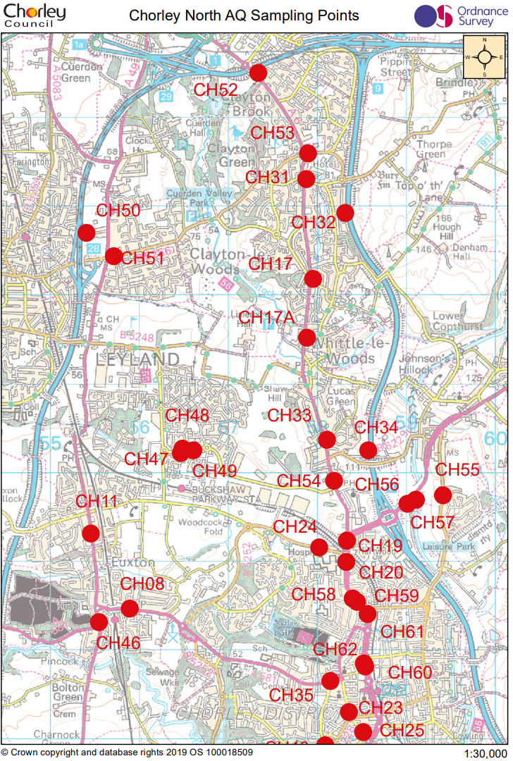

Figure D.2 – Map of Non-Automatic Monitoring Sites Chorley South
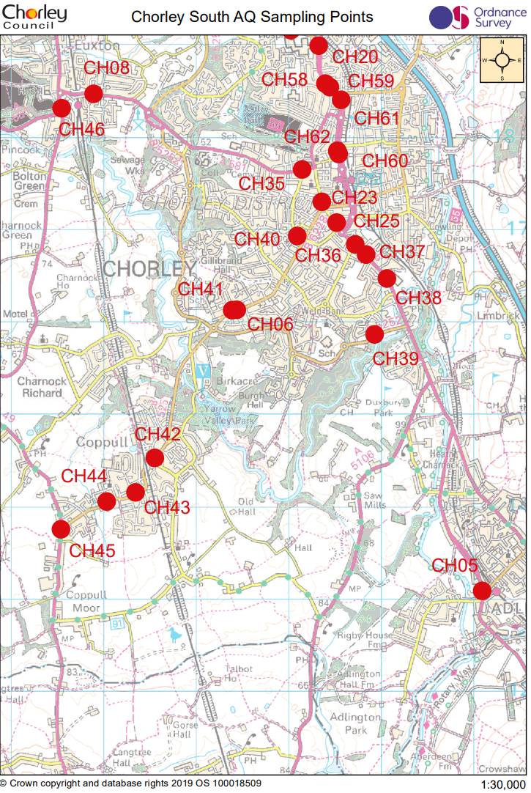

Appendix E: Summary of Air Quality Objectives in England
Table E.1 – Air Quality Objectives in England
Pollutant | Air Quality Objective: Concentration | Air Quality Objective: Measured as
Nitrogen Dioxide (NO₂) | 200µg/m³ not to be exceeded more than 18 times a year | 1-hour mean
Nitrogen Dioxide (NO₂) | 40µg/m³ | Annual mean
Particulate Matter (PM₁₀) | 50µg/m³, not to be exceeded more than 35 times a year | 24-hour mean
Particulate Matter (PM₁₀) | 40µg/m³ | Annual mean
Sulphur Dioxide (SO₂) | 350µg/m³, not to be exceeded more than 24 times a year | 1-hour mean
Sulphur Dioxide (SO₂) | 125µg/m³, not to be exceeded more than 3 times a year | 24-hour mean
Sulphur Dioxide (SO₂) | 266µg/m³, not to be exceeded more than 35 times a year | 15-minute mean

Glossary of Terms
Abbreviation | Description
AQAP | Air Quality Action Plan - A detailed description of measures, outcomes, achievement dates and implementation methods, showing how the local authority intends to achieve air quality limit values’
AQMA | Air Quality Management Area – An area where air pollutant concentrations exceed / are likely to exceed the relevant air quality objectives. AQMAs are declared for specific pollutants and objectives
ASR | Annual Status Report
Defra | Department for Environment, Food and Rural Affairs
DMRB | Design Manual for Roads and Bridges – Air quality screening tool produced by National Highways
EU | European Union
FDMS | Filter Dynamics Measurement System
LAQM | Local Air Quality Management
NO₂ | Nitrogen Dioxide
NO_{x} | Nitrogen Oxides
PM₁₀ | Airborne particulate matter with an aerodynamic diameter of 10µm or less
PM_{2.5} | Airborne particulate matter with an aerodynamic diameter of 2.5µm or less
QA/QC | Quality Assurance and Quality Control
SO₂ | Sulphur Dioxide

References
- Local Air Quality Management Technical Guidance LAQM.TG22. August 2022. Published by Defra in partnership with the Scottish Government, Welsh Assembly Government and Department of the Environment Northern Ireland.
- Local Air Quality Management Policy Guidance LAQM.PG22. August 2022. Published by Defra in partnership with the Scottish Government, Welsh Assembly Government and Department of the Environment Northern Ireland.
- Chorley Council Clean Air Strategy as updated May 2022
- Chorley Council Climate Change Strategy 2022-2024
- Chorley Council Air Quality webpages: https://www.chorley.gov.uk/article/1991/Air-quality?ccp=true
- Chorley Council Climate Change webpages: https://chorley.gov.uk/ClimateChange
- Chorley Council Citizen Space webpage: https://yoursay.citizenspace.com/chorley/
- Chorley Council Official Facebook page: https://www.facebook.com/chorleycouncil
- Chorley Council Official Twitter page: https://twitter.com/ChorleyCouncil
- Check Out Chorley website: https://checkoutchorley.com/cycling/.
- Lancashire County Council public transport website: http://www.lancashire.gov.uk/roads-parking-and-travel/public-transport.aspx
- National Rail train timetable information: https://www.nationalrail.co.uk/
- National Rail offers for rail travel: https://www.daysoutguide.co.uk/

Public Health England. Air Quality: A Briefing for Directors of Public Health, 2017
Defra. Air quality and social deprivation in the UK: an environmental inequalities analysis, 2006
Defra. Air quality appraisal: damage cost guidance, January 2023
Public Health England. Estimation of costs to the NHS and social care due to the health impacts of air pollution: summary report, May 2018
Defra. Environmental Improvement Plan 2023, January 2023
DfT. The Road to Zero: Next steps towards cleaner road transport and delivering our Industrial Strategy, July 2018
The units are in microgrammes of pollutant per cubic metre of air (µg/m³).

