Annual Status Report Appraisal Report

The Annual Status Report sets out new information on air quality obtained by Chorley Council (CC) as part of the Review & Assessment process required under the Environment Act 1995 (as amended by the Environment Act 2021) and subsequent Regulations.
CC does not currently have any active AQMAs within their jurisdiction. Thus, an Air Quality Action plan is not required. However, they have a Local Air Quality Strategy in place.
CC does not currently have any automatic monitoring sites. However, they have continued to trial EarthSense Zephyr continuous automatic particulate monitors at three locations across the borough. The result of this monitoring is indicative and not included in the ASR.
CC undertook passive diffusion tube monitoring of NO₂ at 43 monitoring locations during 2022. There were no exceedances of the annual or short term mean objectives for NO₂ in 2022. The highest recorded concentration was 30.2 µg/m³, recorded at CH61. Recorded concentrations have decreased between 2021 and 2022 at all sites. Most diffusion tubes in the borough have only been active since 2021, making establishing long term trends in the borough difficult. However, at sites that have been in place since 2018, monitoring indicates and overall decreasing trend.
CC has robust QA/QC procedure, which has been appropriately applied to the 2022 monitoring data. Diffusion tubes were deployed in line with the Defra calendar, and instances where this has deviated have been noted. Annualisation was required at four diffusion tube sites (CH40, CH17A, CH54 and CH57). Appropriate calculations have been provided. A national bias adjustment factor of 0.83 was applied to the 2022 monitoring data. Distance correction was not required for any site in 2022.
Defra recommends that Directors of Public Health approve draft ASRs. Sign off is not a requirement, however collaboration and consultation with those who have responsibility for Public Health is expected to increase support for measures to improve air quality, with co-benefits for all. Please bear this in mind for the next annual reporting process.
On the basis of the evidence provided by the local authority the conclusions reached are accepted for all sources and pollutants. Following the completion of this report, Chorley Council should submit an Annual Status Report in 2024.
Commentary
The report is well structured, detailed, and provides the information specified in the Guidance. The following comments are designed to help inform future reports:
- The Council continues to include and respond to comments from previous ASRs. This is welcomed and encourage for future reports.
- The Council continues to priorities air quality despite not having a formal AQAP. It is encouraging to see that the Council has implemented an Air Quality Strategy, which is required of councils without an AQMA from 2023.
- The council has clearly and concisely laid out their priorities for the upcoming year. This is useful.
- The council has provided a long list of measures that are currently being actioned to combat PM_{2.5} in the borough. This is great to see.
- The council has included a good section regarding new developments in the borough. It is encouraging to see the council monitor developments in the borough.
- The council has robust QA/QC procedure and has included the relevant information and calculations. However, it would be beneficial to include a screenshot of the bias adjustment factor spreadsheet for reference.
- There are several places where pollutants and units are not appropriately subscripted or superscripted, in text and tables. Whilst this does not affect the readability of the report, the council should check future reports for such errors.

This commentary is not designed to deal with every aspect of the report. It highlights a number of issues that should help the local authority either in completing the Annual Status Report adequately (if required) or in carrying out future Review & Assessment work.

Issues specifically related to this appraisal can be followed up by returning the attached comment form to Defra, Welsh Government, Scottish Government or DOE.

For any other queries please contact the Local Air Quality Management Helpdesk:
Telephone: 0800 0327 953
Email: LAQMHelpdesk@bureauveritas.com

LAQM Guidance Notes – 2023
Through the Environment Act 2021 and updated Local Air Quality Management Statutory Policy Guidance 2022, the Local Air Quality Management (LAQM) framework has been considerably strengthened. This page highlights some of the changes for delivery to help you prioritise action for improved air quality:
1. Strengthened Criteria for Air Quality Action Plans (AQAPs)
Where a Local Authority is not meeting air quality objectives, they must create an AQAP setting out their intentions to improve air quality in the area. Without current action plans in place, Local Authorities risk negatively impacting their communities by not proactively working to reduce air pollution in the area.
The requirements and guidance around AQAPs were recently strengthened under the Environment Act 2021 and revised LAQM Statutory policy guidance, which Local Authorities must have regard to. The key criteria for action plans are that they:
• set out the measures they will take to secure the achievement, and maintenance, of air quality standards and objectives
• specify a date by which each measure will be carried out
• are revised no later than every five years
2. New Escalation Process for Reporting
To ensure ASRs and AQAPs are delivered on time, Defra has introduced a new reminder and warning letter system for Local Authorities. This system was set out in the LAQM Statutory Policy Guidance 2022, published on 6 August 2022.
From 30 June 2023, Local Authorities with overdue ASRs and AQAPs will start to receive their first reminder letters. As set out in the Tables 1 and 2 below, if reporting requirements continue to be missed, the matter can be escalated to a Section 85 Secretary of State direction to the relevant Local Authority Chief Executive specifying action.
You are therefore advised to ensure all statutory reporting duties for LAQM are met on time. Please refer to the LAQM Statutory Policy Guidance 2022 for more information.

Table 1: Reminder and warning process for ASRs
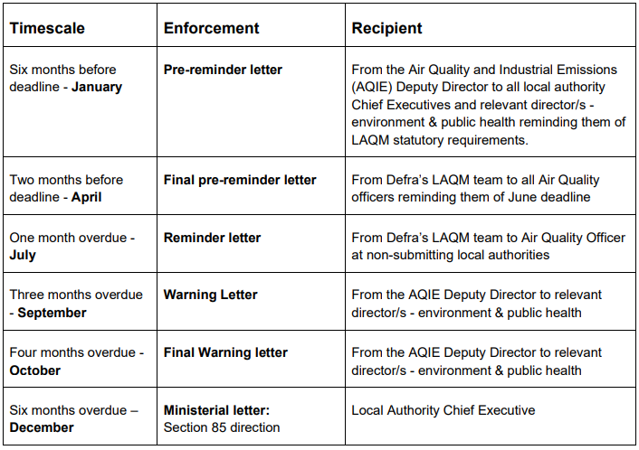
Table 2 – Reminder and warning process for AQAPs - Due to be revised at least every five years
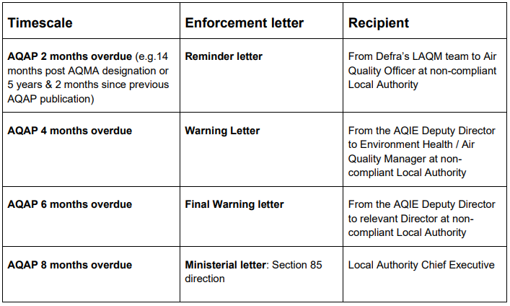

3. Public Bodies Required to Contribute to Action Plans
The Environment Act 2021 amended the Environment Act 1995 to increase the number of public bodies that have a duty to co-operate with Local Authorities for LAQM. Air quality partners are certain other public bodies that a Local Authority identifies as having responsibility for a source of emissions contributing to an exceedance of local air quality objectives. This could be a neighbouring authority, National Highways, or the Environment Agency. Once identified, there is a statutory requirement for such public bodies to engage and to contribute actions they will take to secure achievement of the local air quality objective and to maintain achievement thereafter.
All tiers of local Government are also now required by law to collaborate to address exceedances of Air Quality Objectives. County councils, the Mayor of London and combined authorities have similar duties to air quality partners. The difference is that, when requested, they must contribute to an action plan being prepared by a Local Authority, regardless of whether the local authority has identified them as being responsible for a source of emissions.
Under the new legislation, you may choose to request the support of another public body in the development of an AQAP and the same may be requested of your organisation.
Please refer to the LAQM Statutory Policy Guidance 2022 for more information. Should you require further assistance, please contact the LAQM Helpdesk:
Web: http://laqm.defra.gov.uk/helpdesks.html
FAQs: http://laqm.defra.gov.uk/laqm-faqs/
Tel: 0800 032 7953
Email: laqmhelpdesk@uk.bureauveritas.com
The Air Quality Hub also provides free online information and is a knowledge sharing resource for local authority air quality professionals: https://www.airqualityhub.co.uk/

Appraisal Response Comment Form

Contact Name:
Contact Telephone number:
Contact email address: | UKLAQMAppraisals@aecom.com

Comments on appraisal/Further information:

